Anderson CoWorks

COOPERATIVE WORK SPACE OPPORTUNITIES AT ANDERSON CENTER
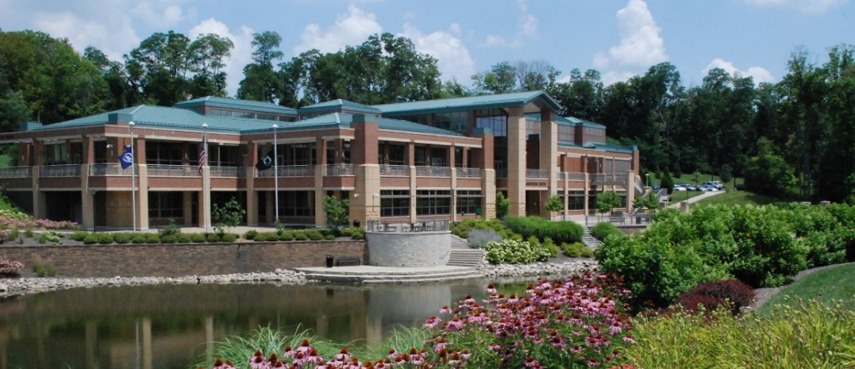
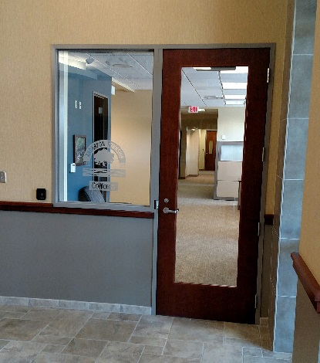

7850 FIVE MILE ROAD
ANDERSON TOWNSHIP, OHIO 45230

OVERVIEW: Anderson’s CoWorks space is the ideal location for someone seeking to start a business, needing space for their business-related project, searching for an option for working at home or the coffee shop, or someone who is seeking a satellite option to occasionally work closer to home.

SITE The CoWorks space is located in the lower level of Anderson Center,
AREA: overlooking Anderson Lake and park, in the heart of Anderson Township between the Anderson Towne Center and Mercy HealthPlex. All the conveniences of home are found in the space, in an ideal location that is also home to the Anderson Area Chamber of Commerce, a 223-seat performing arts theater, meeting facilities, over 110 parking spaces, and wonderful amenities on site and within a short walk. The Center is 1 mile from Exit 69 on I-275 along Five Mile Road, with immediate access to Beechmont Avenue.

SPACE Anderson’s CoWorks space features the following amenities:
FEATURES: - Monthly “dedicated” office rental opportunities, including six walled
offices, six cubicles, and three work rooms – all spaces furnished with
desk or table, and chair or stool
- Greeting/common area and break room with microwave, refrigerator, coffee maker, and sink
- Access during regular Anderson Center business hours, M-F 8am-9pm, Saturday 9am-9pm, and Sunday 9am-6pm, along with free parking
- Mail and parcel service delivery
- Business services, including WiFi and scanning services
- Printing and copying services (included in monthly fee)
- Use of CoWorks conference room, as well as access to adjacent meeting spaces for rent in Anderson Center (which are subject to availability and additional costs)
- Access to the Anderson Area Chamber of Commerce, also located in Anderson Center, including training/networking opportunities often held on site (note: Chamber membership NOT included in CoWorks program)

FEES & Monthly access to the CoWorks space entails three levels of membership.*
SPACES: - “Senior Office Partner” memberships, four are issued at $375/month,
and provide private, dedicated, secure use of walled offices with
desk and related furniture with window view to Lake or Atrium.
- “Junior Office Partner” memberships, three are issued at $175/month, and provide private, dedicated, secure use of a walled interior office.
- “Associate” memberships, dedicated desks in work rooms or cubicles - fifteen are issued at $125/month
* Notes: - Shared spaces do not currently exist as all desks have been
converted into dedicated spaces or work rooms.
- Township residents receive a 10% discount off membership
- Prices do NOT include at $150 refundable security deposit

FOR INFO Steve Sievers - Anderson Township Assistant Administrator for Operations
CONTACT: 7850 Five Mile Road - Anderson Township, Ohio 45230
(513) 688-8604 - ssievers@andersontownshipOH.gov
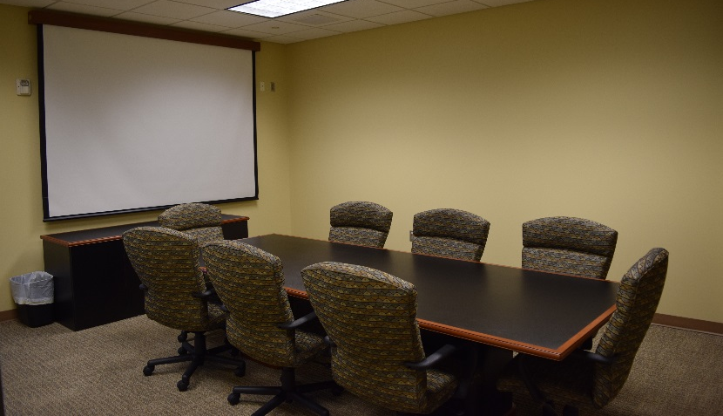
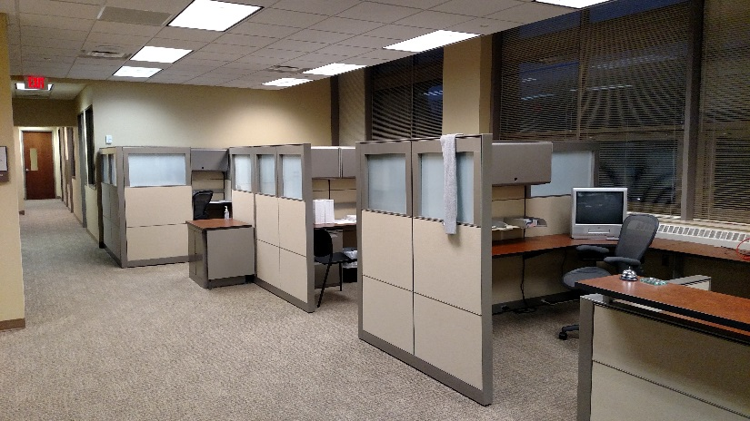

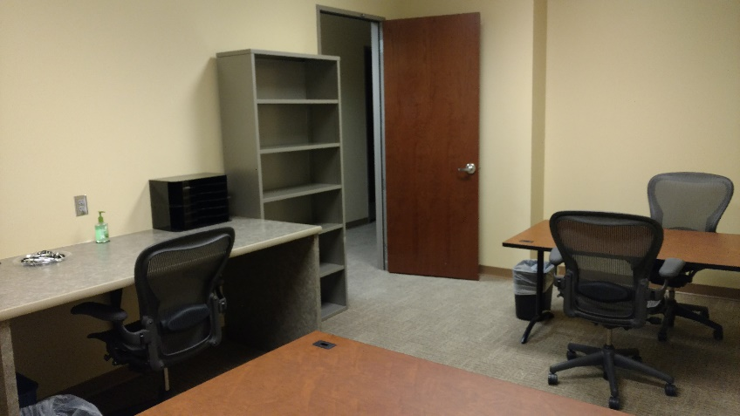
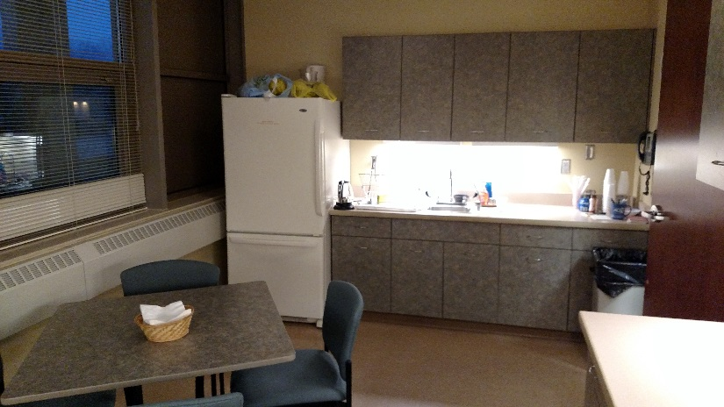
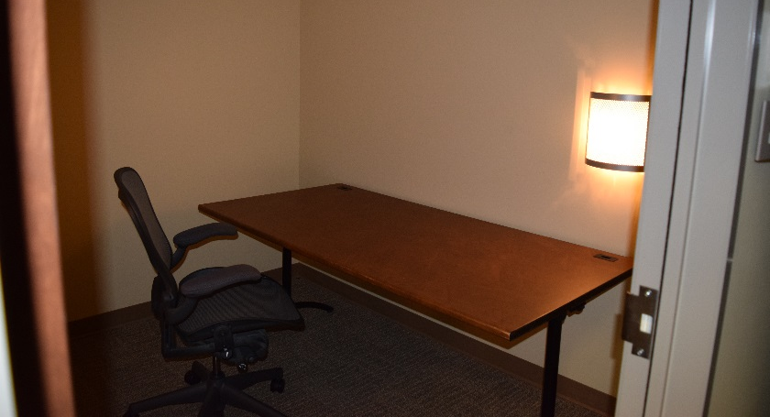
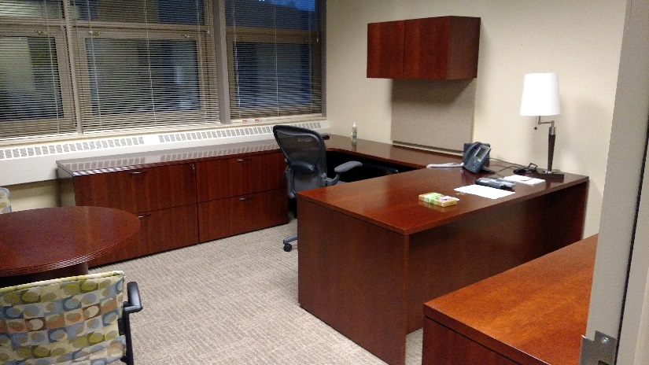
Furnished Break Room Area “Typical” “Junior Office Partner” Workspace
“Associate” Cubicle Area Entering From Atrium Conference Room With Screen & Whiteboard
Copy/Printer/Fax Area

Typical “Senior Office Partner” Workspace “Typical” Associate Designated Work Room Area
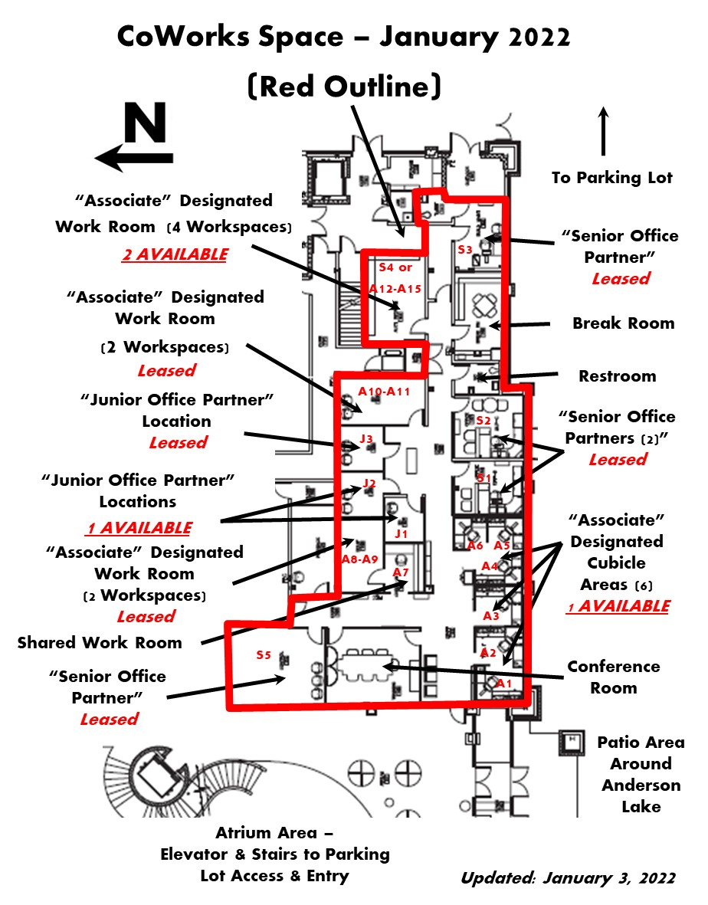
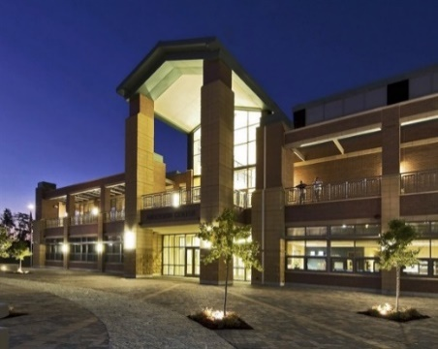
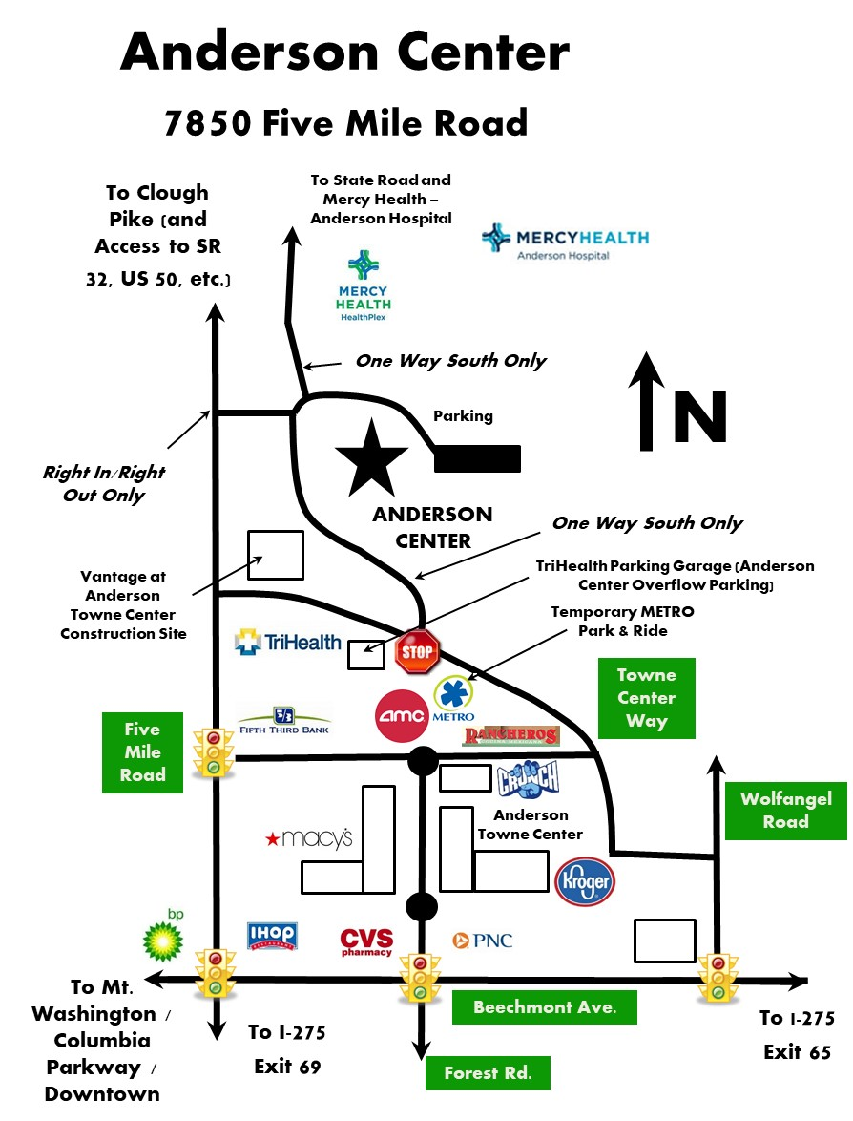
00

